1 You can your Pi in **Headless mode** (using TightVNC on your PC/Laptop to remotely control the Pi). To do this the Pi must first be connected to your network. You can simulate a network by connecting the Pi directly to the Ethernet Port of your PC/Laptop. (You can even power the Pi from a USB port)

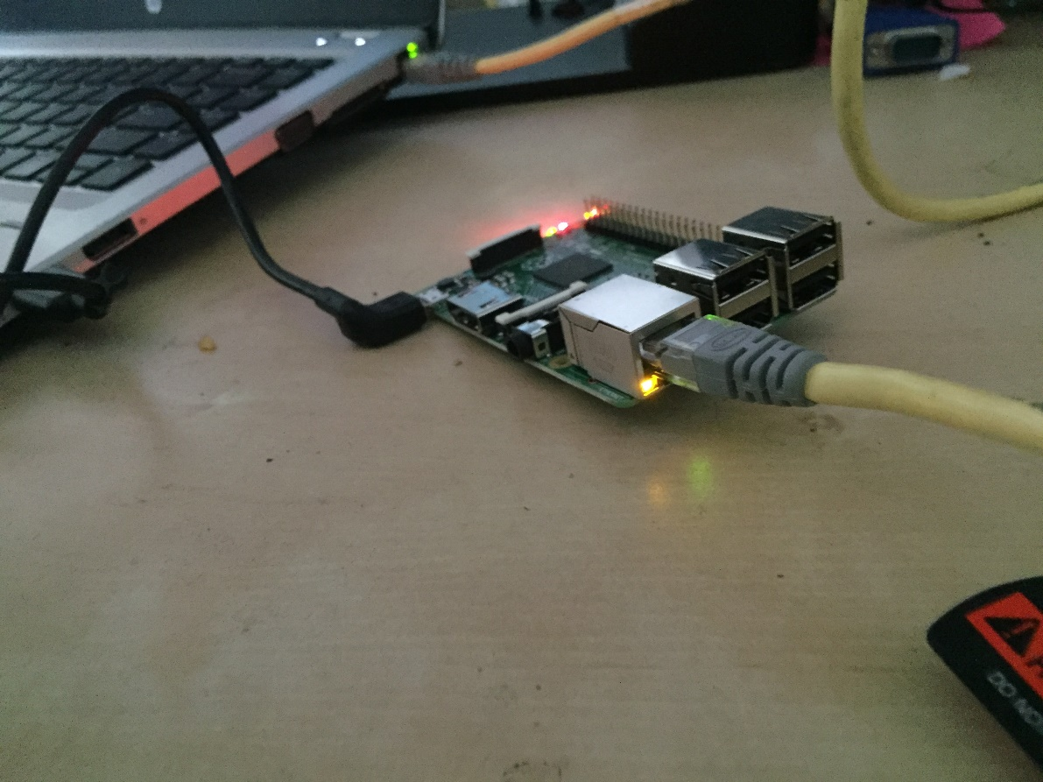

Windows Users

2 The first step is to enable Internet Sharing. Go to the Control Panel and Open the Network and Sharing Centre

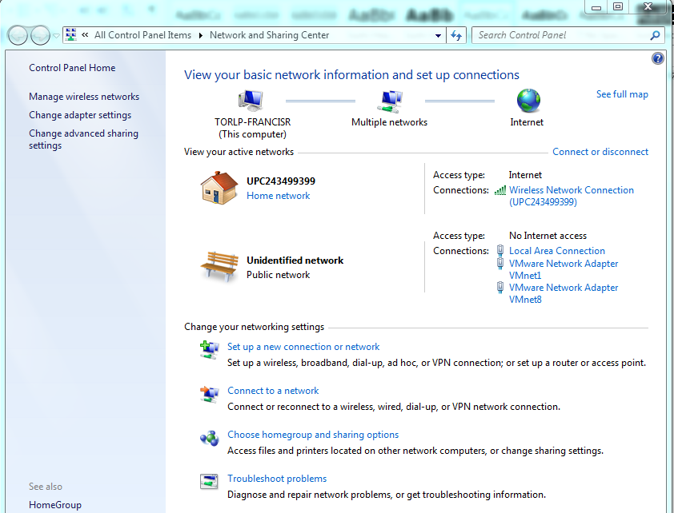

3 Now click on the **Wireless** connection you are using to connect to the Internet, click on **Properties** and then click the **Sharing** tab.

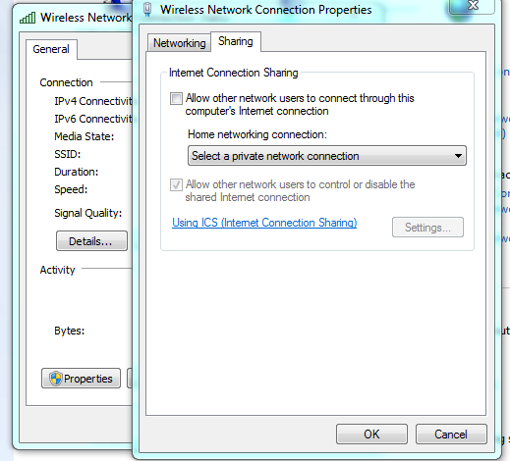

4 Now allow sharing the Wifi connection with the **Local Area Connection.**

*In windows 10 the home networking drop down may not be present.*

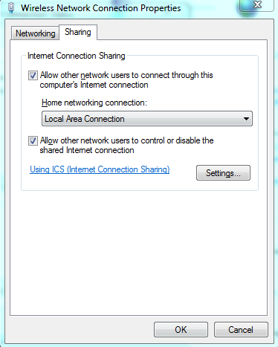

By default windows will manage a private network to the Local Area Network and will automatically provide a **private** IP Address to the Pi (or any device) connected to it.

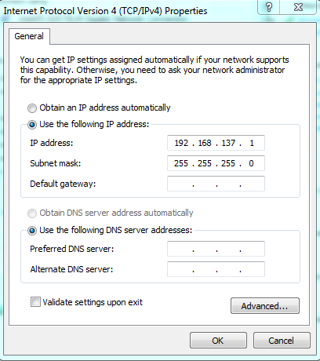

The Pi Address will be dynamically allocated from the same IP Range.

***For Apple Mac OSX Users you can achieve the same by enabling Internet Sharing in the Sharing option of System Preferences. The Default IP Range for Mac OSX will be 192.168.3.0/24.***

5 The address the Pi will get may vary each time the Pi is connected. Open a Command Prompt and ping the following host (assuming your have not changed the hostname of your Pi)

ping raspberrypi.mshome.net

***For Mac OSX users you should find that the arp table is updated automatically.***

Another method of finding the Pi is to ping each available IP address on the Subnet the Pi is connected to. A command line batch file ‘findmypi.bat’ is included to help automate this.

Once you have run this once, you can now check the arp table to see what computers are known: run this command in a Command Prompt/Terminal Window

arp -a

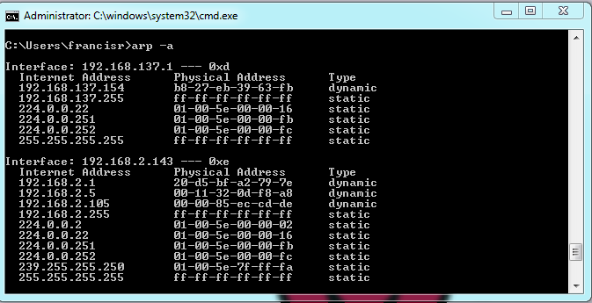

Look at the list to find the MAC Address of your Pi. You can then remotely access your Pi!.

*Once you have located your Pi, you can then use Putty to connect to it. To access the Desktop of the Pi you will need to install TightVNC on both your PC and your Pi. Refer to other Sushi cards in this collection to find out how to do this.*

***For Mac OSX users you can open a Terminal Window.***

5 If you want to keep the Pi on the same Static IP address, you can set this address in the Network Manager. The next time the Pi restarts it will have the same address. However this is only safe when you know you are going to connect the Pi to the same network (via the Ethernet Port) the next time you use it. This option also allows you to set a DNS value to ensure your Pi can navigate around the internet.

In a Terminal Window edit the file /etc/dhcpcd.conf

$ sudo nano /etc/dhcpcd.conf

Add the following lines to the end of the file:

interface eth0

static ip_address=192.168.137.5/24

static routers=192.168.137.1

static domain_name_servers=8.8.8.8

*Reboot the Pi.*

When you eventually get to the UI you will see these settings reflected in the Network Manager:

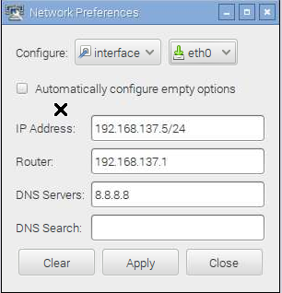

*8.8.8.8 is google’s DNS server you may use a different value if needed.*

Mac OSX Users

1 The first step is to enable Internet Sharing. Go to System Preferences and click on Sharing

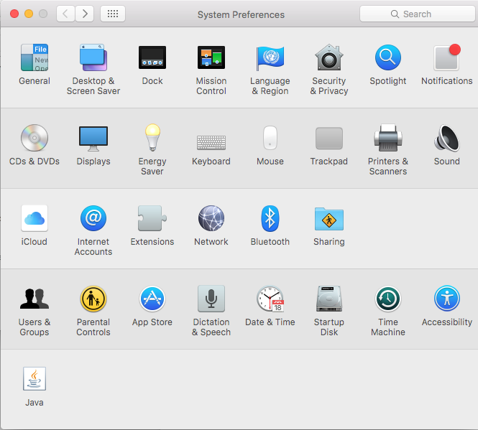

2 Now click on Sharing option and Share the Wifi connection with the LAN/Ethernet connection

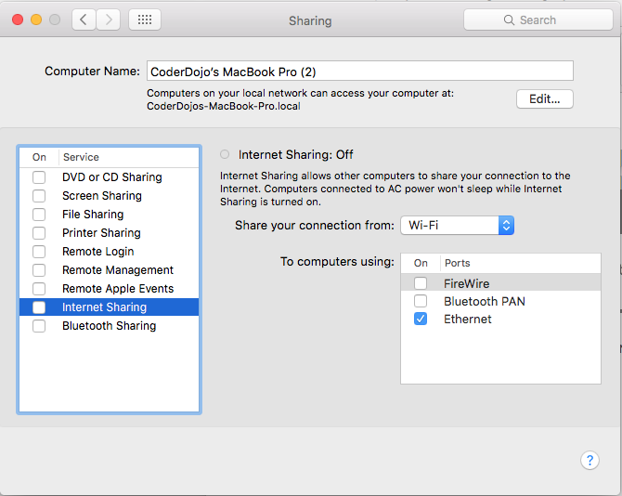

3 Now start the sharing by clicking on the Internet Sharing option and clicking Start

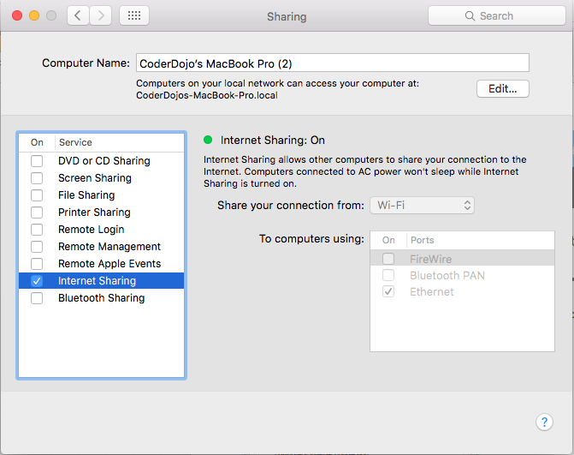

By default Mac OSX will manage a private network to the Local Area Network and will automatically provide a **private** IP Address to the Pi (or any device) connected to it.

The Pi Address will be dynamically allocated from the same IP Range.

***The Default IP Range for Mac OSX will be 192.168.3.0/24. The Mac will be 192.168.3.1 and the Pi will be allocated an address from the same range.***

4 The address the Pi will get may vary each time the Pi is connected. One method of finding the Pi is to ping each available IP address using ping. This has been automated with a utility called *nmap*.

Download and install this utility from [www.nmap.org](http://www.nmap.org).

$ nmap -v -sn 192.168.3.0/24

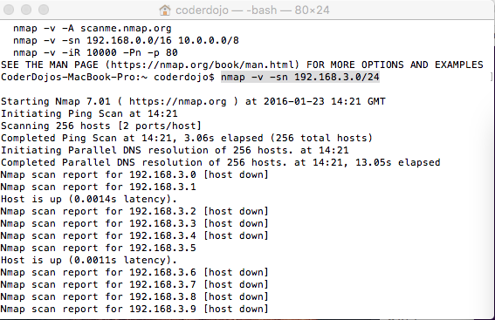

Look at the list of results of nmap to find the MAC Address of your Pi. If only the Pi is connected then you will see the Pi with an IP address greater than 192.168.3.1!. In this example the Pi has been allocated an address of 192.168.3.5.

*Once you have located your Pi, you can then use a Terminal session to connect to it. To access the Desktop of the Pi you will need to install TightVNC on both your Mac and your Pi. Refer to other Sushi cards in this collection to find out how to do this.*

*Useful References:*

[*http://carbonstone.blogspot.ie/2014/02/connecting-to-pi-from-laptops-ethernet.html*](http://carbonstone.blogspot.ie/2014/02/connecting-to-pi-from-laptops-ethernet.html)